House prices up in February
9:51 AM Tuesday Mar 11, 2014
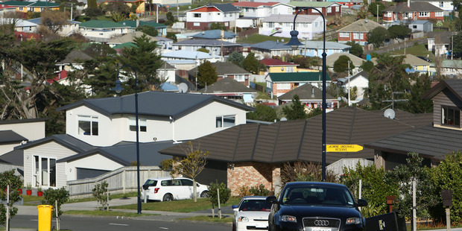Photo / Hagen Hopkins
New Zealand house prices rose in February reversing the falls of December and January. Record median prices were recorded in Waikato/Bay of Plenty, Hawkes Bay and Canterbury/Westland.
The Real Estate Institute just released data showing how in Auckland, the stratified house price index hit an all time high.
But sales volumes were down on the same time last year in all regions except Northland and Central Otago.
"So far, the housing market has been supported by housing shortages, high net immigration and low (but rising) mortgage rates....Eventually the slowdown in sales volume growth will start to impact on prices, but evidence to date is mixed."
ANZ senior economist, Mark Smith
Last month, 6125 dwellings sold, down 7.6 per cent on last February.
National median price rose $33,000 to $415,000 compared to last February and were up $13,000 or 3.2 per cent on January this year.
"The results for February show further evidence that the national sales volume trend is easing, with only two of twelve regions showing an increase in sales volumes compared to February 2013," said institute chief executive Helen O'Sullivan.
"Market feedback suggests that first homebuyers may be tentatively returning - with some assistance - to certain markets. This is by no means a consistent message, with views decidedly mixed across the country; some regions are reporting increasing interest from first home buyers, while others report little in the way of activity."
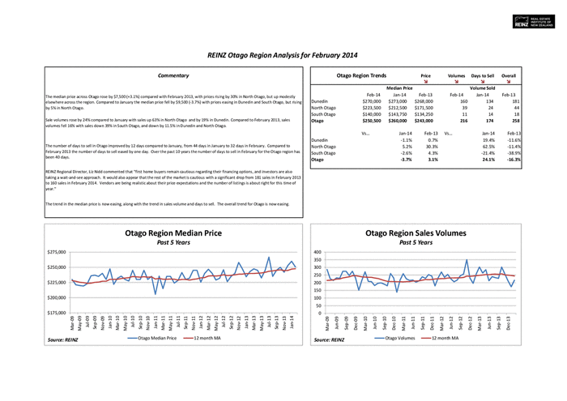
p. 12
Loading Loading
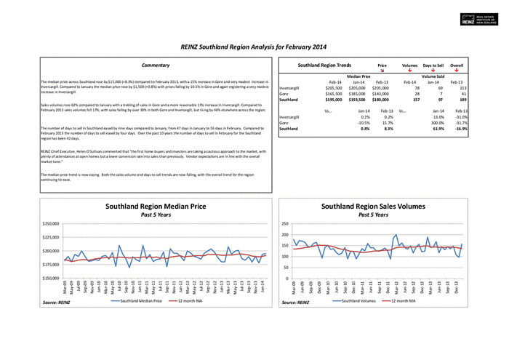
To print the document, click the "Original Document" link to open the original PDF. At this time it is not possible to print the document with annotations.
Auction numbers grew by more than 28 per cent in the 12 months to February but the proportion of sales by auctions in Auckland fell 37.1 per cent of sales last February to 31.9 per cent of sales in February this year.
See the latest property values in your suburb with CoreLogic's interactive charts, published yesterday
Property expert Jonno Ingerson, answered reader questions about the housing market yesterday. View the discussion here.
- NZ Herald

